**WeGot Data Visuals**

**With the Request and Response JSONs**

**Pie Chart:**

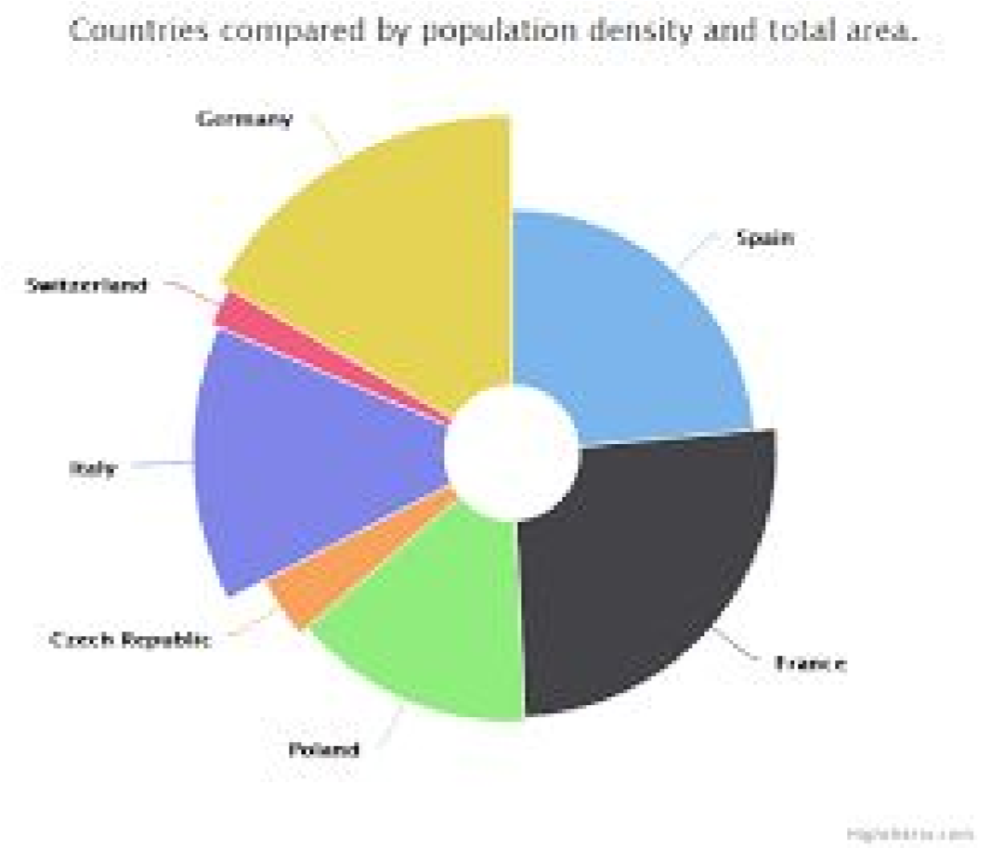

**Fetch the quantity of water from different Sources in the site for the given date range.**

Request:

{

“fromDate”:”10-01-2018”,

“toDate”:”14-02-2018”,

“uid”:”userID”,

“chartType”:”pie”

}

Response:

[

{name: 'Source1', value: 61.41 },

{name: 'Source2', value: 11.84 },

{name: 'Source3', value: 10.85 },

{name: 'Source4', value: 12.85 }

]

Queries :

1. What is uid represents? Is Any formats exists?
2. how to find site details like

Apartment Name -

Block Name -

Flat/Door No -

1. w2_water_type vs w2_water_source_type ??

Report app to DB:

[SELECT](http://54.229.208.9/phpmyadmin/url.php?url=http://dev.mysql.com/doc/refman/5.5/en/select.html) * FROM `w2_water_source_type`

To fetch all available water sources and their id’s.

**Tree Map:**

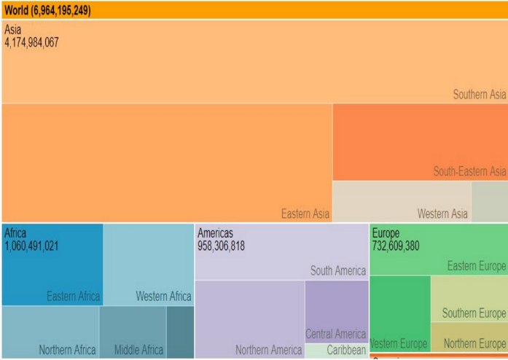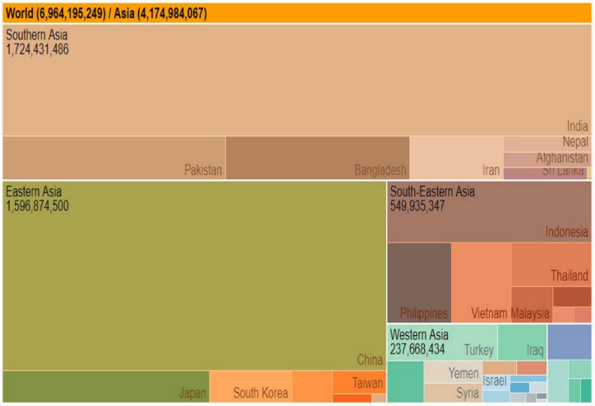

Request:

{

“fromDate”:”10-01-2018”,

“toDate”:”14-02-2018”,

**Fetch the individual residence consumption in their respective blocks for the given date range.**

Request:

{

“fromDate”:”10-01-2018”,

“toDate”:”14-02-2018”,

“uid”:”userID”,

“chartType”:”TreeMap”

}

Response:

[

{ "key": "BlockA", "region": "House1", "value": 25500100 },

{ "key": "BlockA", "region": "House2", "value": 1231231 },

{ "key": "BlockB", "region": "House1", "value": 1231231 }

]

**Bubble Chart:**

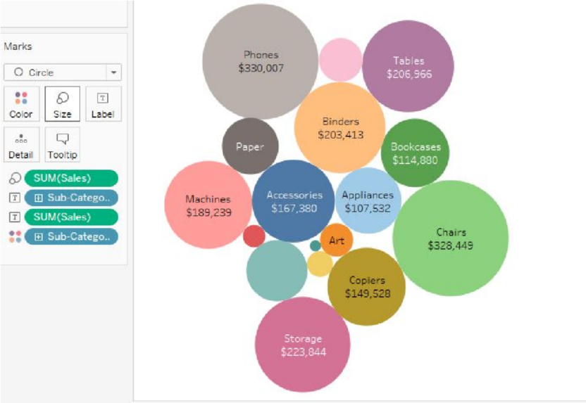

**Fetch the house numbers with their consumption values to highlight the high consumers for a given date range.**

Request:

{

“fromDate”:”10-01-2018”,

“toDate”:”14-02-2018”,

“uid”:”userID”,

“chartType”:”BubbleChart”

}

Response:

[

{"id":"BlockA-House1","value":"200"},

{"id":"BlockA-House2","value":"300"},

{"id":"BlockB-House3","value":"400"},

{"id":"BlockC-House4","value":500}

]

**Raw/Treated/STP Comparison:**

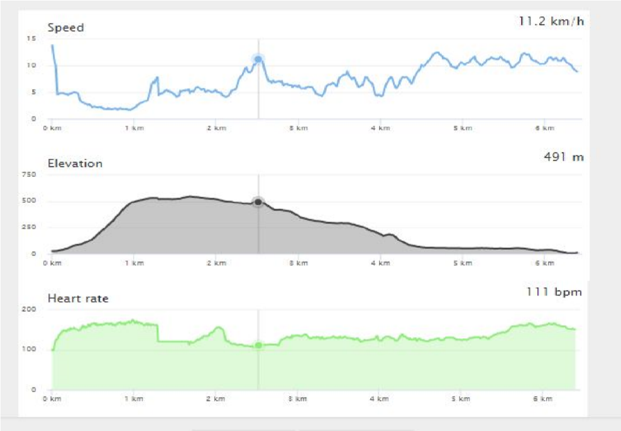

**Fetch the three different varieties of water with their demand on an hourly basis for a given date range.**

Request:

{

“fromDate”:”10-01-2018”,

“toDate”:”14-02-2018”,

“fromTime”:”9AM”,

“toTime”:”12PM”

“chartType”:”RTS”

}

Response:

Below is the example:

xData – It is the log timestamp and data – Values

{

"xData": [09:00,09:10,09:20,09:40,10:15,10:45,11:00,11:45,11:50,12:00],

"datasets": [{

"name": "Raw",

"data": [833,524,441,651,961,566,617,728,823,844],

"unit": "kl",

"type": "area",

"valueDecimals": 1

}, {

"name": "Treated",

"data": [126,217,217,27,127,130,32,133,35,136],

"unit": "kl",

"type": "area",

"valueDecimals": 0

}, {

"name": "STP",

"data": [101,98,103,115,124,128,133,138,138,141],

"unit": "kl",

"type": "area",

"valueDecimals": 0

}]

}

Sample taken from:

<https://cdn.rawgit.com/highcharts/highcharts/057b672172ccc6c08fe7dbb27fc17ebca3f5b770/samples/data/activity.json>

**Gantt chart:**

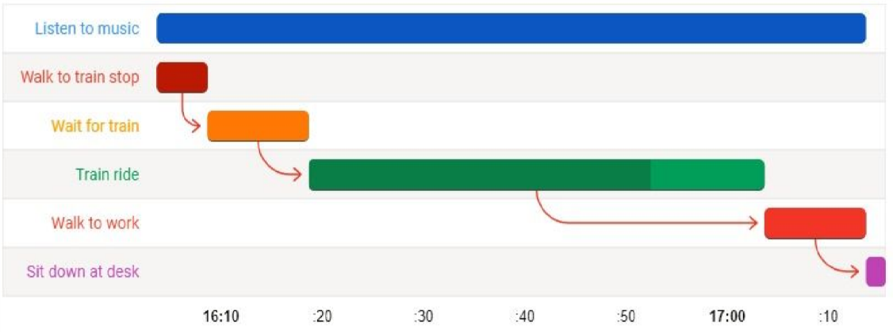

**Fetch the ON/OFF states of each pump for a given date and their yield during the ON period.**

Request:

{

“date”:”10-01-2018”,

“uid”:”userID”,

“chartType”:”ganttchart”

}

Response:

[

{”source”:”pump1”, start: 123123, end: 12313123123,”yield”:”2”},

{”source”:”pump2”, start: 86400000, end: 123400000,”yield”:”4”}

{”source”:”pump3”, start: 86445560, end: 12434000,”yield”:”5”}

]

Note: Start / End – Timestamp

**Sparkline Chart:**

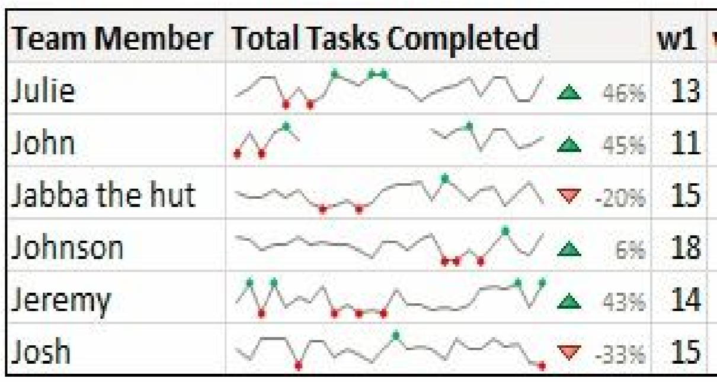

**Compares all the sources and their performances for the given week in terms of their yield**

Request:

{

“fromdate”:”10-01-2018”,

“todate”:”20-01-2018”,

“uid”:”userID”,

“chartType”:”sparkline”

}

Response:

{

"data": [{

"name": "Source1",

"SLData": [12,32,45,0,23],

"bar": [32,0,23,53,45,77,0],

"yeildValue": 232,

"yeildPercentage": 88

},

{

"name": "Source2",

"SLData": [43,37,99,55,0],

"bar": [32,0,23,53,45,77,0],

"yeildValue": 232,

"yeildPercentage": 88

}]

}

**Heat Map:**

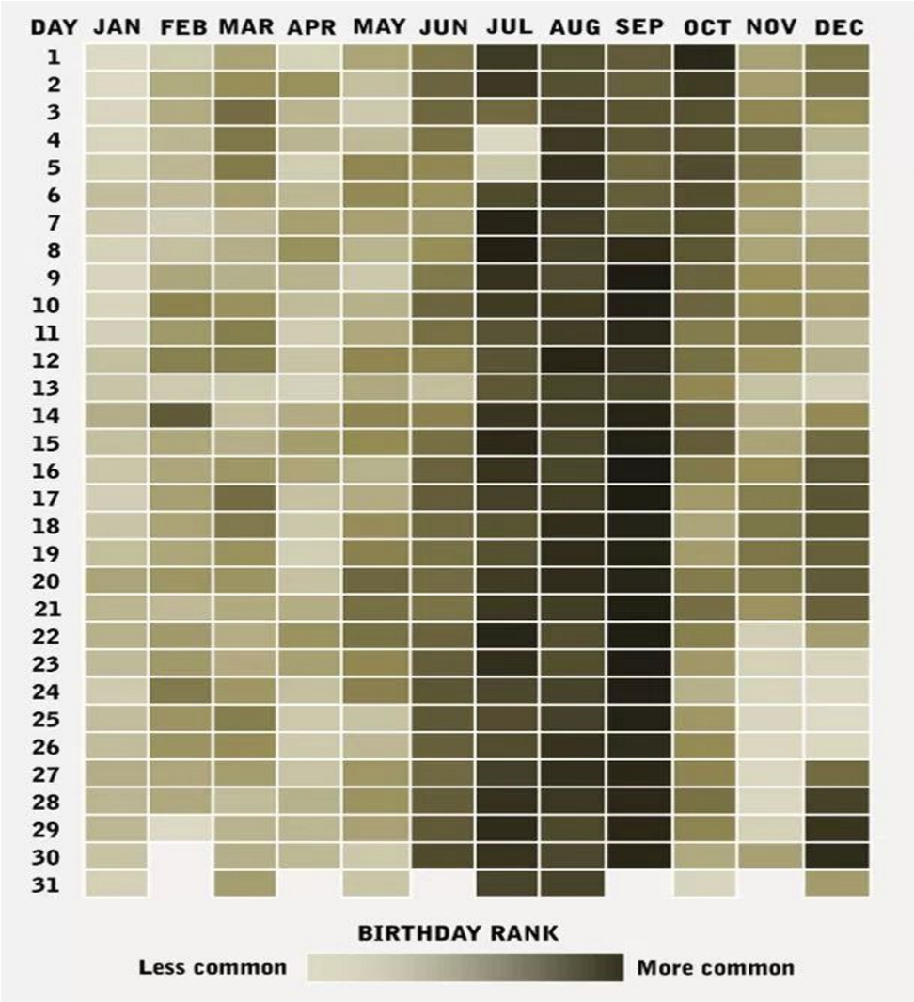

**Fetches the consumption of water for the given date as a heat map.**

Request:

{

“fromdate”:”10-01-2018”,

“todate”:”20-05-2018”,

“uid”:”userID”,

“chartType”:”heatmap”

}

Response:

{

"data": [{

"xValue": "JAN 2017",

"yValue": "01",

"Data": 12312312

},

{

"xValue": "JAN 2017",

"yValue": "02",

"Data": 43234

},

{

"xValue": "JAN 2017",

"yValue": "03",

"Data": 4356354

}]

}

**Follow UP Histogram:**

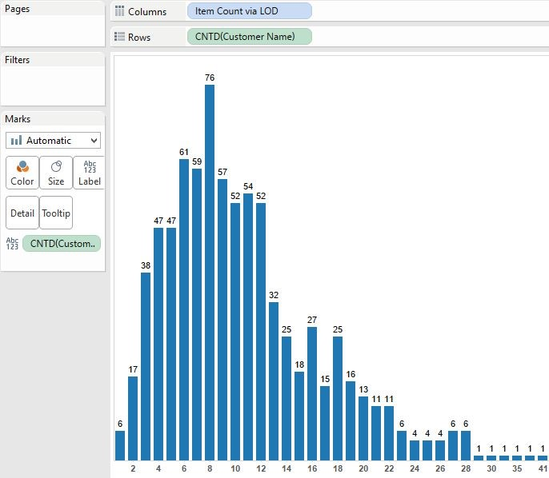

**Fetches the consumption for the selected date in the heat map.**

Request:

{

“date”:”10-01-2018”,

“uid”:”userID”,

“chartType”:”heatmap”

}

Response:

[{

"name": "2018-05-10",

"data": [{

"bin": 9:00,

"count": 30000

},

{

"bin": 10:00,

"count": 80000

},

{

"bin": 11:00,

"count": 180000

},

{

"bin": 12:00,

"count": 40000

},

{

"bin": 13:00,

"count": 40000

},

{

"bin": 14:00,

"count": 40000

}]

}]